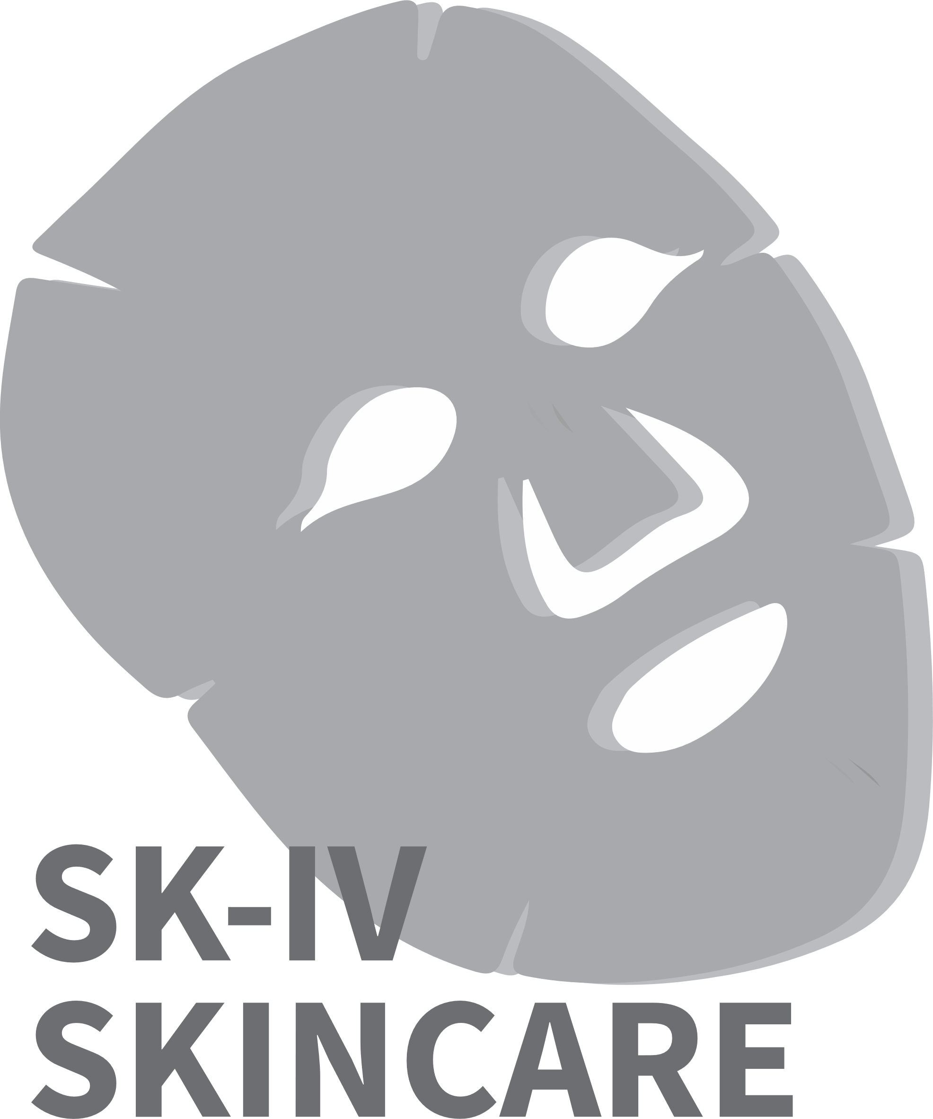**Mission Statement:**

Our mission is to design both an **informative** and **interactive** game such that players of the game can increase their general knowledge of skincare products through it and learn how to customise their own specific skincare routine.